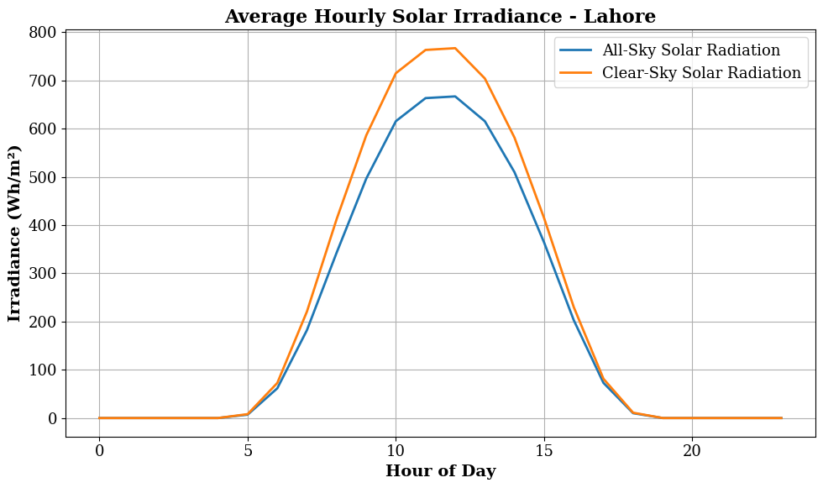
- 🌞 HOURLY SOLAR IRRADIANCE SUMMARY

- 🔵 All-Sky Solar Radiation:
- Max (Peak Hour): 666.83 Wh/m² at hour 12
- Min: 0.00 Wh/m² at hour 0
- Mean: 200.43 Wh/m²

- 🟡 Clear-Sky Solar Radiation:
- Max (Peak Hour): 766.85 Wh/m² at hour 12
- Min: 0.00 Wh/m² at hour 0
- Mean: 231.96 Wh/m²

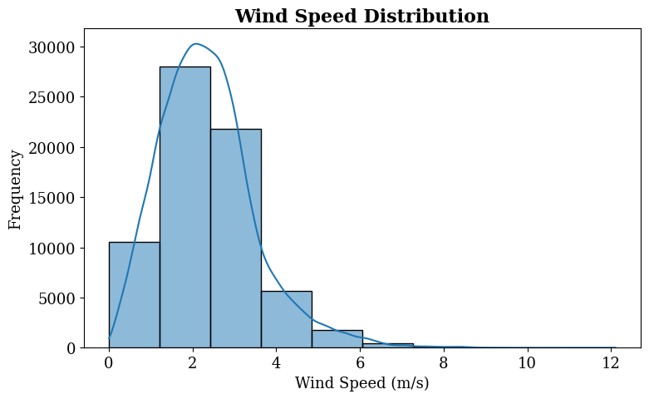

- 🌬️ WIND SPEED SUMMARY
- Minimum: 0.01 m/s
- Maximum: 12.10 m/s
- Mean: 2.36 m/s
- Median: 2.25 m/s
- 25th Percentile: 1.55 m/s
- 75th Percentile: 2.98 m/s

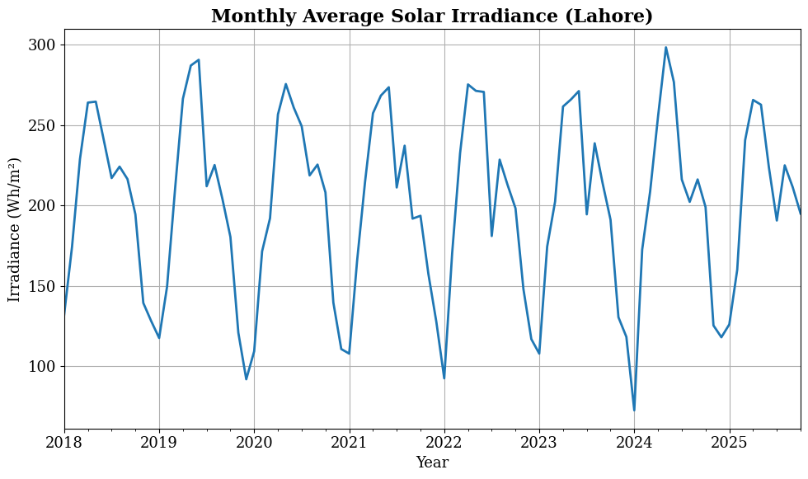

- 📅 MONTHLY SOLAR RADIATION SUMMARY
- Peak Month: 2024-05 → 298.45 Wh/m²
- Lowest Month: 2024-01 → 72.51 Wh/m²
- Mean Monthly Value: 200.38 Wh/m²
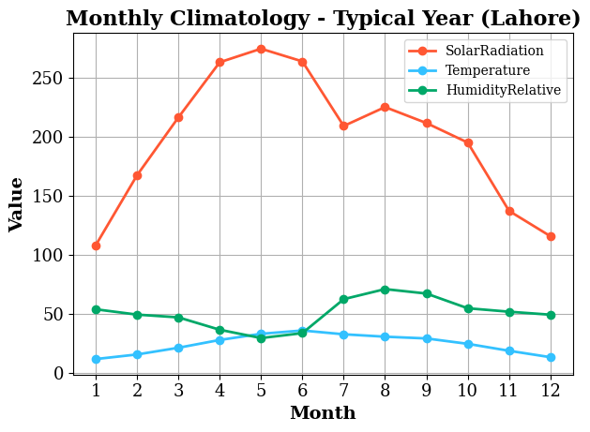

- 📅 MONTHLY CLIMATOLOGY - NUMERICAL SUMMARY

- 🌞 SOLAR RADIATION
- Peak Month: 5 → 274.30 Wh/m²
- Lowest Month: 1 → 108.17 Wh/m²
- Mean Value: 198.85 Wh/m²

- 🌡️ TEMPERATURE
- Peak Month: 6 → 36.22 °C
- Lowest Month: 1 → 12.07 °C
- Mean Value: 24.88 °C

- 💧 RELATIVE HUMIDITY
- Peak Month: 8 → 71.19 %
- Lowest Month: 5 → 29.82 %
- Mean Value: 50.81 %

- 📌 SEASONAL INTERPRETATION
- Solar Radiation Range: 166.14 Wh/m²
- Temperature Range: 24.15 °C
- Humidity Range: 41.36 %

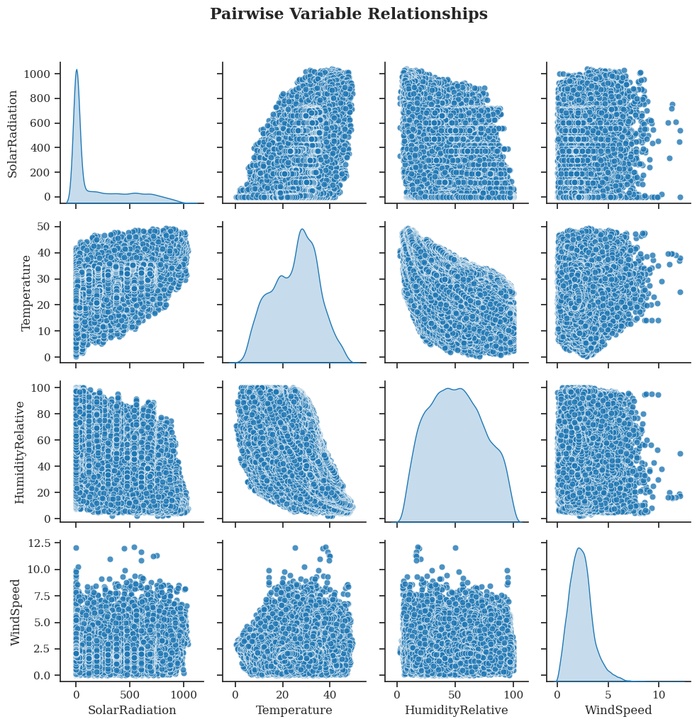

- 📌 PEARSON CORRELATION COEFFICIENTS
    - SolarRadiation Temperature HumidityRelative WindSpeed
- SolarRadiation 1.000000 0.516588 -0.489672 0.117313
- Temperature 0.516588 1.000000 -0.417025 0.095798
- HumidityRelative -0.489672 -0.417025 1.000000 -0.095748
- WindSpeed 0.117313 0.095798 -0.095748 1.000000

- 🔍 KEY RELATIONSHIPS
- SolarRadiation vs Temperature: 0.517
- SolarRadiation vs Humidity: -0.490
- SolarRadiation vs WindSpeed: 0.117
- Temperature vs Humidity: -0.417
- Temperature vs WindSpeed: 0.096
- Humidity vs WindSpeed: -0.096

- 📌 DISTRIBUTION SHAPE (SKEWNESS)
- SolarRadiation 1.132034
- Temperature -0.138972
- HumidityRelative 0.123201
- WindSpeed 0.999155
- dtype: float64

- 📌 INTERPRETATION RULES
    - Skew > 1 → Highly right-skewed distribution
    - Skew between -1 and 1 → Approximately symmetric
    - Skew < -1 → Left-skewed distribution

- 📌 EXTREME VALUES (OUTLIER CHECK)

- SolarRadiation
- Lower Bound: -575.89, Upper Bound: 959.82
- Temperature
- Lower Bound: -3.91, Upper Bound: 53.88

- HumidityRelative
- Lower Bound: -22.25, Upper Bound: 123.06

- WindSpeed
- Lower Bound: -0.59, Upper Bound: 5.12
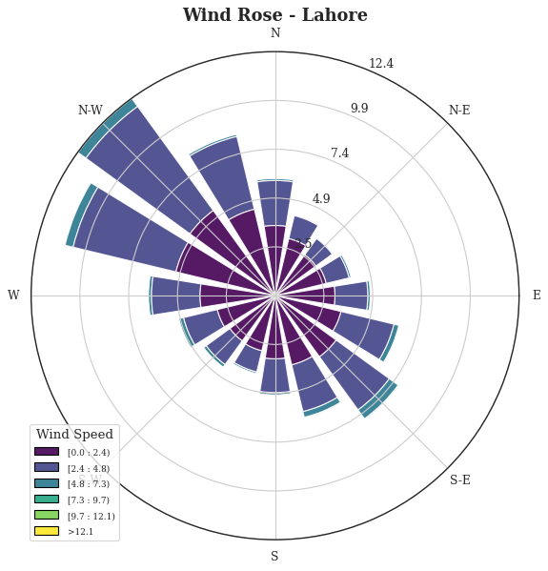

🌬️ WIND ROSE - NUMERICAL ANALYSIS

📊 WIND SPEED STATISTICS
- Min Wind Speed: 0.01 m/s
- Max Wind Speed: 12.10 m/s
- Mean Wind Speed: 2.36 m/s
- Median Wind Speed: 2.25 m/s
- Std Dev: 1.17 m/s

🧭 WIND DIRECTION STATISTICS
- Min Direction: 0.00°
- Max Direction: 359.80°
- Mean Direction: 205.30°
- Dominant Wind Direction: 270.00°

📌 WIND DIRECTION SECTORS

Wind Sector Percentage Distribution:
- WindSector
- W 31.352267
- N / NE 26.170231
- S 21.549205
- E 20.928296
- Name: proportion, dtype: float64

🌪️ WIND SPEED CLASS DISTRIBUTION
- WindClass
- 2–4 (Light) 50.737786
- 0–2 (Calm) 41.029687
- 4–6 (Moderate) 7.234689
- 6–8 (Fresh) 0.879500
- 8–10 (Strong) 0.105189
- 10+ (Very Strong) 0.013149
- Name: proportion, dtype: float64

⚠️ EXTREME WIND EVENTS ANALYSIS
- Upper Threshold for Extreme Wind: 5.12 m/s
- Number of Extreme Wind Events: 1840
- Percentage of Extreme Events: 2.69%

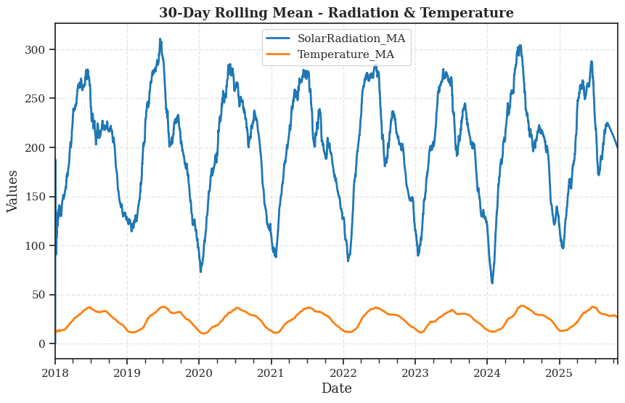
- 📈 30-DAY ROLLING MEAN ANALYSIS

- 🌞 SOLAR RADIATION (30-day Moving Average)
- Max Smoothed Value: 310.86
- Min Smoothed Value: 0.00
- Mean Smoothed Value: 200.02
- Peak Date: 2019-06-17
- Lowest Date: 2018-01-01

- 🌡️ TEMPERATURE (30-day Moving Average)
- Max Smoothed Value: 38.78
- Min Smoothed Value: 9.59
- Mean Smoothed Value: 25.03
- Peak Date: 2024-06-21
- Lowest Date: 2018-01-01

- 📌 SMOOTHED CORRELATION (Trend-Level Relationship)
- Correlation (30-day trend): 0.866

- 📉 VARIABILITY REDUCTION (Smoothing Effect)
- Solar Radiation Std Reduction: 219.73
- Temperature Std Reduction: 1.51

- 📌 SEASONAL TREND INSIGHT
- Solar Trend Range: 310.86
- Temperature Trend Range: 29.19

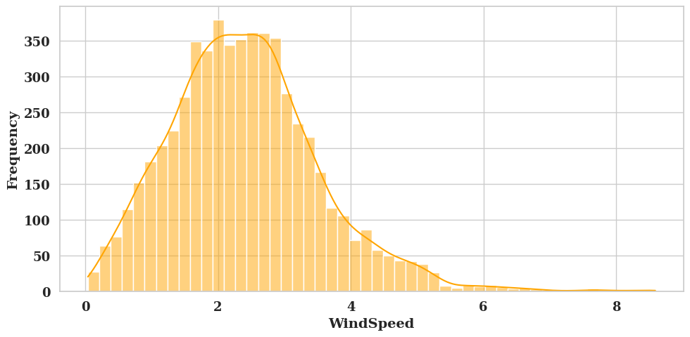
Numerical Presentation of all the frequency plots

📊 FEATURE DISTRIBUTION STATISTICS

- ==================== ClearSkyRadiation ====================
- Min: 2.58
- Max: 1040.38
- Mean: 452.88
- Median: 464.33
- Std Dev: 288.12
- Skewness: -0.010
- Kurtosis: -1.245
- Outliers Count: 0

- ==================== SolarRadiation ====================
- Min: 2.45
- Max: 1040.18
- Mean: 395.89
- Median: 374.66
- Std Dev: 275.35
- Skewness: 0.257
- Kurtosis: -1.111
- Outliers Count: 0

- ==================== DirectRadiation ====================
- Min: 0.09
- Max: 1033.87
- Mean: 305.42
- Median: 259.32
- Std Dev: 257.31
- Skewness: 0.566
- Kurtosis: -0.762
- Outliers Count: 0

- ==================== DiffuseRadiation ====================
- Min: 3.00
- Max: 557.57
- Mean: 189.09
- Median: 181.46
- Std Dev: 114.61
- Skewness: 0.338
- Kurtosis: -0.585
- Outliers Count: 6

- ==================== SolarZenith ====================
- Min: 10.67
- Max: 90.00
- Mean: 71.98
- Median: 87.48
- Std Dev: 23.20
- Skewness: -1.027
- Kurtosis: -0.218
- Outliers Count: 0

- ==================== Temperature ====================
- Min: 2.91
- Max: 48.29
- Mean: 26.03
- Median: 27.31
- Std Dev: 10.36
- Skewness: -0.154
- Kurtosis: -0.908
- Outliers Count: 0
- ==================== HumiditySpecific ====================
- Min: 1.13
- Max: 23.99
- Mean: 9.07
- Median: 7.12
- Std Dev: 5.56
- Skewness: 0.812
- Kurtosis: -0.534
- Outliers Count: 0

- ==================== HumidityRelative ====================
- Min: 5.82
- Max: 100.00
- Mean: 41.83
- Median: 38.74
- Std Dev: 21.77
- Skewness: 0.524
- Kurtosis: -0.453
- Outliers Count: 0

- ==================== Pressure ====================
- Min: 96.45
- Max: 99.95
- Mean: 98.29
- Median: 98.36
- Std Dev: 0.80
- Skewness: -0.140
- Kurtosis: -1.181
- Outliers Count: 0

- ==================== WindSpeed ====================
- Min: 0.04
- Max: 8.59
- Mean: 2.42
- Median: 2.33
- Std Dev: 1.13
- Skewness: 0.778
- Kurtosis: 1.619
- Outliers Count: 101

- ==================== WindDirection ====================
- Min: 0.20
- Max: 359.80
- Mean: 207.51
- Median: 224.70
- Std Dev: 100.41
- Skewness: -0.349
- Kurtosis: -1.085
- Outliers Count: 0

